

Emotional Design – Memoriable Tourism App

Group 1 Report

By Shailendra Kushwaha

Claudio Rodríguez

Dilip​ Poudel

User Experience

DIG4TF002-3002

2018

Contents

1 Introduction 1

2 User Study 2

2.1 User Profile 2

2.2 Task Analysis 3

2.3 Affinity Diagram 4

3 Design 5

3.1 Scenario 5

3.2 Scenario review report 5

3.3 Scenario revision 6

3.4 Extra Scenarios 6

3.4.1 Scenario 2 (Current Available Technology) 6

3.4.2 Scenario 3 (20 years from now) 7

4 Prototyping 8

4.1 Paper prototype 8

5 Contributions 11

5.1 Shailendra 11

5.2 Dilip Poudel 12

5.3 Claudio 12

# Introduction

The main purpose of this project is to come up with an app, trough emotional design, that is focused travels. The app in question will be referred as ***Memoriable Tourism App***. The focus point of its design is the emotional attachment of the user travel’s, trough technology.

We carried out a user study, to find out who are user is, what is the context of the app’s use and what would be them main requirements of our users. Once we got those things clear, we created scenarios to test our design with the users. That way we could get confirmation of the requirements and functionalities for our app and find extra hidden features that didn’t come trough after the interviews from our user study.

Finally, we developed a low fidelity prototype (paper prototype) were the main concept and the app’s features can be further tested and tuned.

Also, to understand user needs we did interview with user from 3 different countries with semi-structured questions mainly. After interview and getting complete scripting we did task analysis on the basis of most often used key word of their activities that they mentioned during interview. After task analysis we moved to design part starting by developing scenario. First, we developed scenario on the basis of all the research that we have done by user study, user interview, and task analysis. Now we had developed our scenario, then next we again took our designed scenario to two users same before interviewed and one new user in order to get their view. Here, we got some suggestions mainly relating to add some more features to our app. These consultations helped us to polish our previous scenario and revise it with little modification. Now finally, we were in point to design our paper prototype, this gave us clear picture of how our app will work. Here, we draw user flow path to interact with app.

# User Study

This phase of the project is about, the research and study of target users. The collection of information of end users and their profiles were completed in this step. This phase plays really a vital role to demonstrate the good design of our mission/products. As our responsibilities in this group projects, the data about the users profiles was analyze individually from each members of team. Besides these, a semi-structure interview was also conducted about the travelling. From the transcript of interview getting from each member had collected and taken it to the further step ‘Task Analysis’ to get the affinity Diagram. Hence, the different process and tasks are as so far we have done are mentioned here.

## User Profile

In order to find our *user profile*, we asked a defined set of questions to different people, as shown on *Table 1*. As the design of our app, can vary depending of the type of user, we asked people to provide fundamental information about themselves, such as age, gender, nationality and occupation. We also asked which operating system they use on their devices, number of smart device, so we could better understand the technological environment in which our potential users could be.

We asked people to rate their use of social media between 1 – 5 (from lowest to highest). We also researched about their personal thinking on travelling. For eg: would they like to travel alone or with company? Would they like to travel in every years or not? Do they like to share their trip with others or not? What do they think about repeating the place to visit? In overall, here is our User Profiles’ stastics.



Table 1. User Profile.

## Task Analysis

Task analysis is the phase of the design process that is helpful to analyse data collected during user study and interview script. It is one of the first key component of design process in order to design user interface. It helps to see and understand users, their activities they do and the environment they perform those activities.

In our task analysis from scripts of the 3 different team members we got a lot of common activities of users that they were doing in different context. Our team member first individually analysed their script got during user interview and we collected frequently used activities words. Then after individual analysis we all put our analysed data together to find similar finding and then combine to make single task analysis.

We got different activities and the environment where users were involved during their trip. Activities such as travelling in different places and having sight visit, networking with people in during travel, picking up places get suggestions friends, other people, google and other sources. Experiencing food and drinks of different culinary with variety local taste and sharing their activities with friends and other people after trip and memorizing by looking old photos on phones and other sources were some more activities that we got.

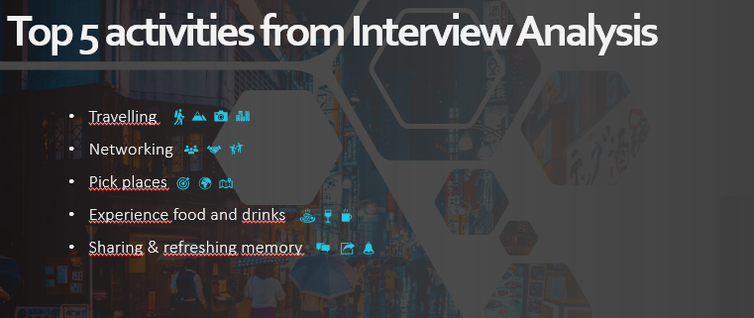

## Affinity Diagram

Affinity diagram is a relational visual representation of a team’s insights and observations. It is a method used meaningfully cluster observations and insights from research. So, it is a process of organizing many ideas taken together to filter and get better one among them. Hence, it basically means grouping a common experience. In this data or ideas are hierarchically grouped revealing problems, needs or solutions for the end user. It is one of the faster way to find and represent large amounts of data that helps in making strategy. This is a great tool for interpretation that help us synthesize the information we’ve gathered without subjecting it to predefined notions we have. Affinity diagram is used mainly after making various simple observations during research, interviews and surveys.

In our project we used affinity diagram after we had done scripting after the interviews. We started writing down all insights and observations seen in scripts and then place them randomly. Now, we gathered our team ideas collected individually and then organised them hierarchically and finally from hierarchy we picked up the required features.

# Design

## Scenario

Andy is feeling very stressed and decides he needs a holiday. He opens memorable app, looks at the suggestion trips the app offers.

He gets excited about the culinary experience one recommendation offers and saves it for a future trip. Then he looks at the older trips registered on the app, sees ones with his old friend Jenni and realizes they haven’t talked in a while.

Through the app he sends the trip suggestion and asks if she wants to join. She excitedly replies “YES! Let’s do it!” and they continue chatting, catching up and planning for trip.

## Scenario review report

The concept and main functionalities of our app were easily understood by both people that were familiar and unfamiliar with Memorable Tourism App. We got suggestions for additional or supporting features for our app, which led us to update our scenario, only to make it clearer and more readable.

The comments we got were mainly positive, with people saying such such as “Could become the Facebook of travel” and “It’s perfect for someone I know and people that love to travel all the time”.

Some of the main suggested features we got are as follows:

* Dashboard where you can post and comment
* Words and useful phrases in other languages
* Possibility to buy tickets and accommodation trough the app
* Forum for people’s suggestions about places, hotels, etc
* Blacklist (for blocking people)

## Scenario revision

Winter is coming, and Andy is already feeling very stressed and tired of routine. He thinks that it’s time to plan a holiday.

Andy opens from his phone memorable app and looks for trip suggestions the app offers. He gets excited about the culinary experience one recommendation offers and saves it for a future trip.



He then looks at older trips he made, registered on the app and sees one he made with his old friend Jenni. Andy realizes they haven’t talked in a while. Through the app he sends the trip suggestion to Jenni and asks if she wants to join. She excitedly replies “YES! Let’s do it!” and they continue chatting, catching up and planning for a future trip.

## Extra Scenarios

### Scenario 2 (Current Available Technology)

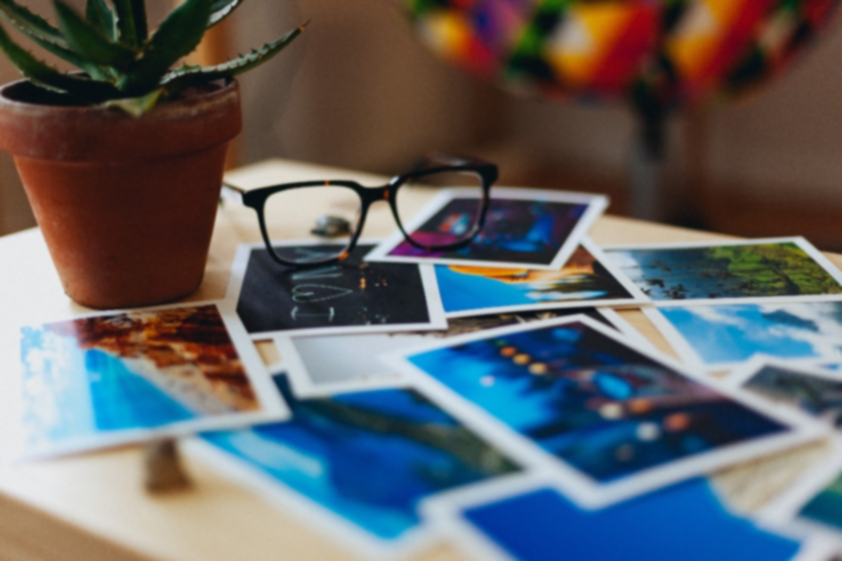Adam realizes his honeymoon is one month away and opens his memorable tourism app.

After relieving his honeymoon memories trough, the app, he checks memoriable’s offers and books a romantic trip for two.

### Scenario 3 (20 years from now)

Granma and little Tommy look at old pictures and curious little is full of questions.

Granma can’t remember every detail, but the embedded memoriable tourism app on Granma’s glasses do.

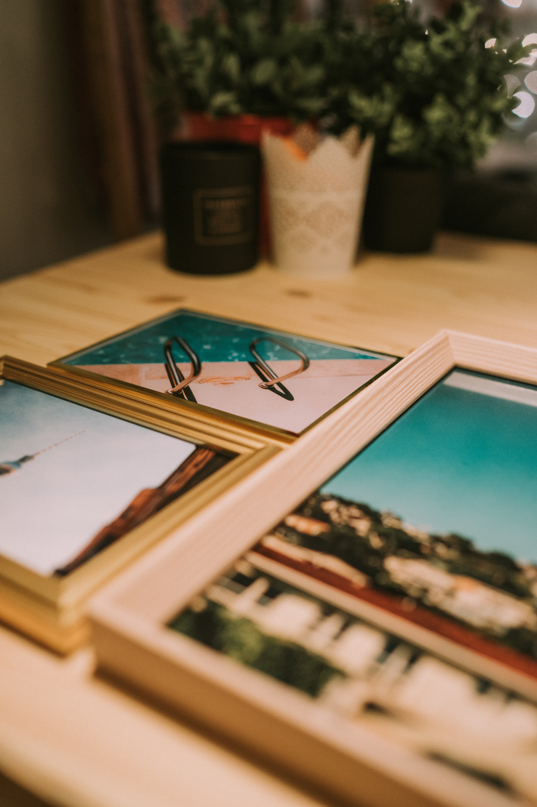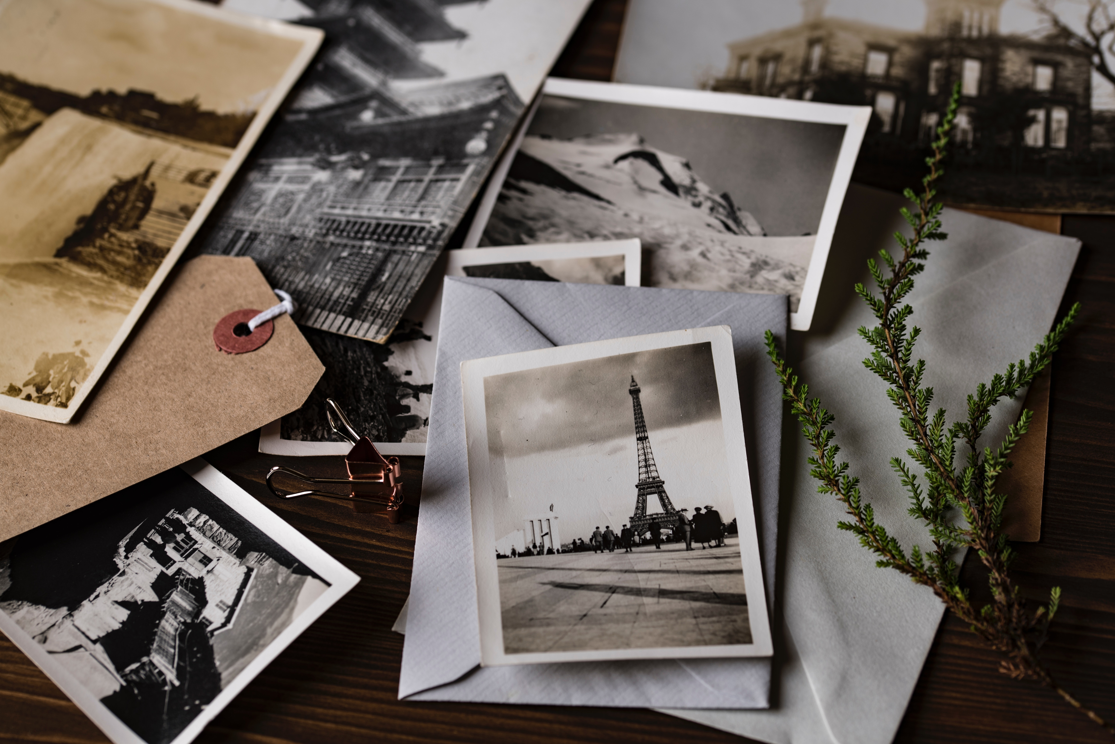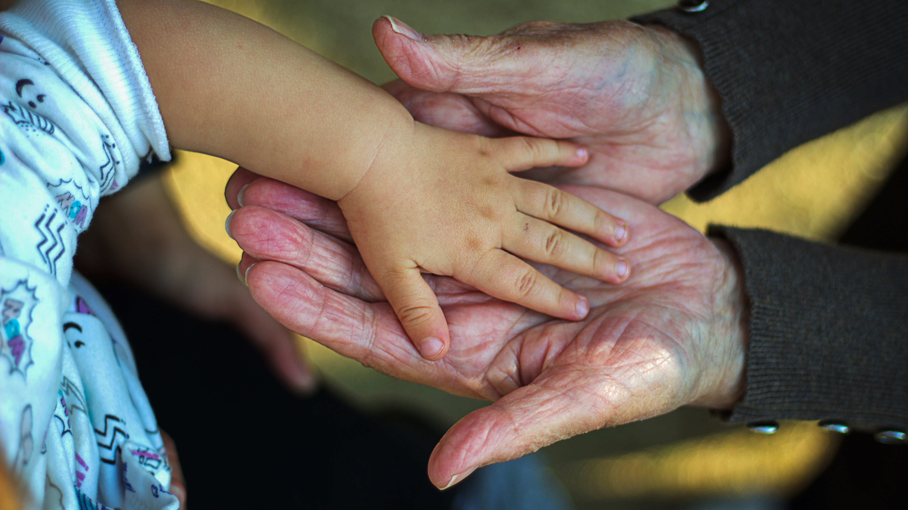

# Prototyping

Prototype is an early sample of products which evaluate the concepts of design. It is a first or early version of a product, from which other forms are developed. We’ve implemented the concept of prototyping on paper-based to make our design concept of Tourism app more reliable. It becomes our test case and is the model on the basis of which the final product is developed. It is important stage to develop and implement early ideas that are tested for feedback to advise developer on improvement to be made.

In our project we used it as a important phase to represent our ideas to meet user needs in pictorial form in the form of paper based prototype. This step we performed after interview script was gained which made base for the task analysis. And finally after task analysis we developed scenario for our target user and this after further revision we did paper prototyping.

## Paper prototype

Picture 1. Memoriable Travel App Opening, Sign In and Welcome Screens.

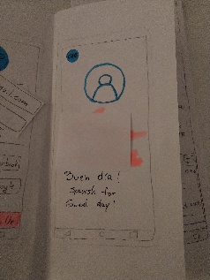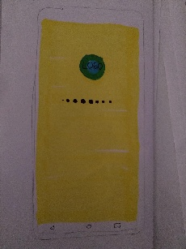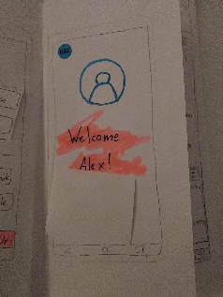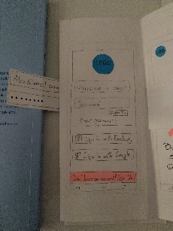

In this phase of our designing process, we’ve rendered our design concepts and the tasks in paper prototype. We expect that this low fidibility will support for further high fedilibity of prototype. This prototype is showing that what’s going on in the project and how it will be implemented of this design concept according to user study profile and task analysis. This prototype is totally based on the revised scenario and users’ experiences.

Picture 2. Example that shows how to share a trip.

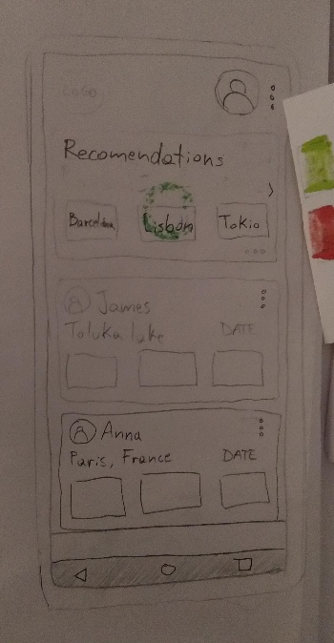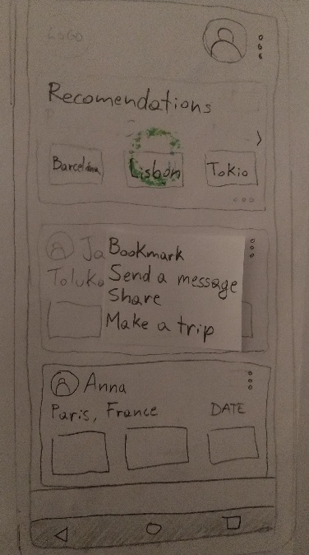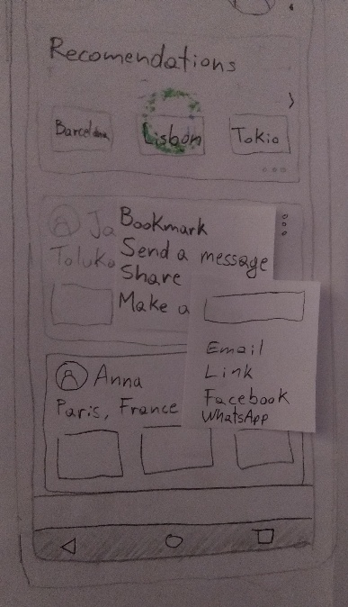

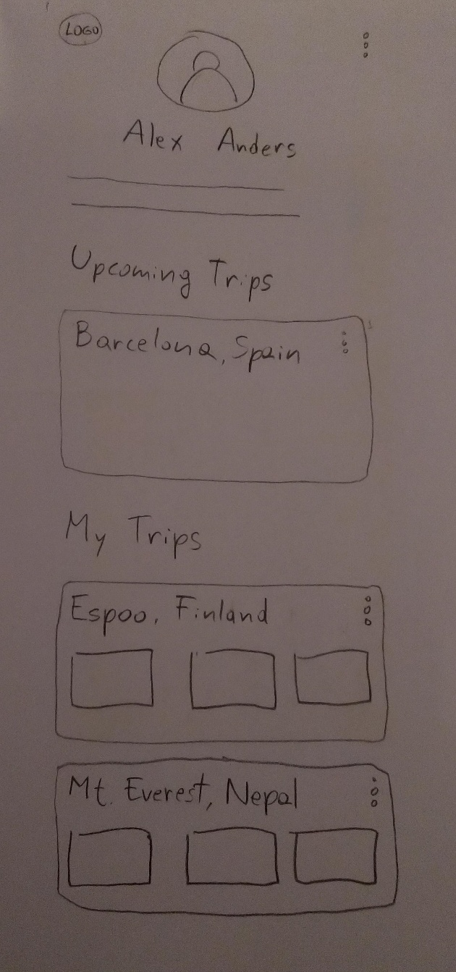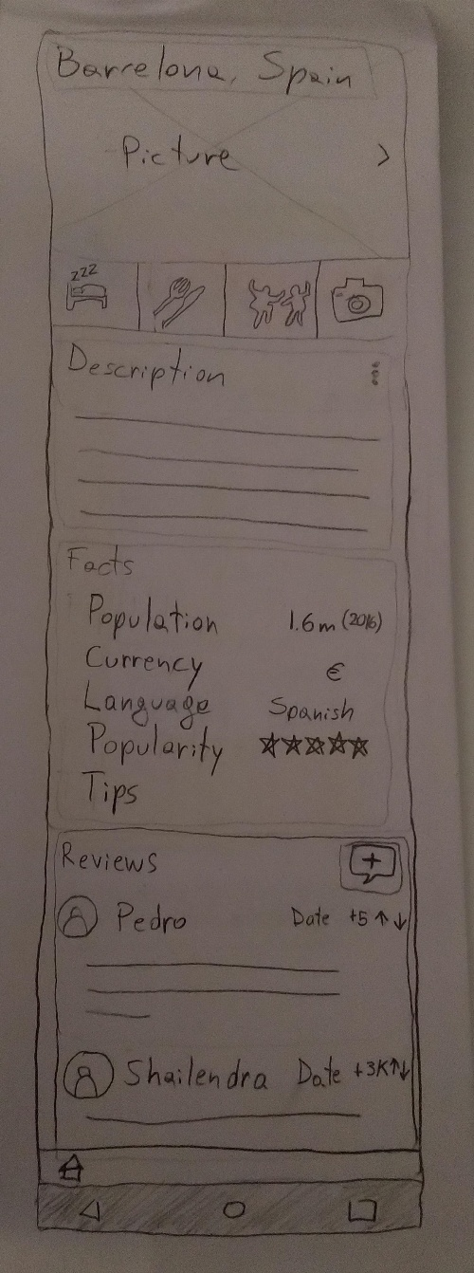§

Picture 4. Personal profile page.

Picture 4. Suggested location (Barcelona) page.

# Contributions

## **Shailendra**

Since, beginning of this course, I was feeling very energetic and curios to learn how user experience is implemented in a product. With the end of the course I got chance to learn all the steps, process and different tools involved in user experience design. And further in prototype course I’m going to get chance to develop my design learning a lot. So, during different phases of the course I got chance to contribute in different individual and group assignments and projects. Doing so many discussions and chat over whats app with team members to make success to our presentations meaning full. Here, are some of the contributions I personally made with team and individually in this course.

* I participated in our first presentation along with my other team very supportive team members. Our presentation title was User Experience for which I prepared presentation focusing steps involve in user experience design.
* I Heuristic evaluation to school peppi system on the basis of 10 main evaluation properties of Heuristic.
* Here I created user profile from two users from Nepal who are good traveler and frequently go for trip to create user profile as per need our my project.
* I interviewed one of my user for 19:58 mins asking him mainly semi-structured interviews which remain very good.
* I wrote script for the interview conducted with the user.
* Until now I have my user interview script, this was time to do task analysis. For this I used affinity diagram to do task analysis individually, then I along with my other two team members combined our common and most prioritized finding.
* I developer scenario based on all the research until now I have done.
* Now again I showed my scernario developed to two new user inorder to take their feedback, which they like and put some suggestions with more feature to be implemented.
* So, I discussed those findings after feed back to my team members and we implemented some of our common.
* Then after I participated in prototype that along with my team presented in class and got feed back from teacher and other fellow students.
* Then I presented final presentation to the class until now all things I have done with my team with final output in the form of paper prototype.
* Finally, I contributed in writing final report for my course.
* During whole course I actively participated in team activities in class and remotely as well.

## Dilip Poudel

I believe that I’ve contributed in the following ways:

* Contributed in the first presentation ‘User Experience’ to research about the introduction part and presented it on ppt file.
* Research and study about the users’ profiles to collect data
* Collected the data according to profiles from the field
* Conducted a Semi-structure interview and wrote the transcript
* Completed the task analysis with team members by analyzing transcript of audio records.
* Contributed to create the paper prototype of our Tourism App according to design concepts and based on revised scenario.
* Present it on during presentation.
* Wrote the final report with group members.
* Supported to the team in every group meeting and made the communication strong.

## Claudio

During this project I have contributed in the following:

* Setting up the structure and styling reports and power point presentations
* Question ideas for user profile and interview
* Analysis of user profile and interviews
* Discussion to pick main tasks and functionalities from collective data
* Scenario ideas
* Analysis of scenario feedback
* Implementation of feedback suggestions to design
* Paper prototype design
* Edition of presentations and reports